**Some Application of Trigonometry**

# Trigonometric Ratios

Ratio of the sides of a right triangle with respect to the acute angles is called the **trigonometric ratios**

of the angle.

Trigonometric ratios of acute angle A in right triangle ABC are given below:

Sin*A*  side opposite to*A*  *BC*  *p*

hypotenuse *AC h*

cos*A*  side adjacent to*A*  *AB*  *b*

hypotenuse *AC h*

tan*A*  side opposite to*A*  *BC*  *p*

side adjacent to*A AB b*

* 1. iv.

cosec *A* 

hypotenuse  *AC*  *h*

sideopposite to*A BC p*

* 1. sec *A* 

hypotenuse

 *AC*  *h*

* 1. vi.

side adjacent to*A AB b*

cot *A*  sideadjacent to*A*  *AB*  *b*

side opposite to*A BC p*

The values of the trigonometric ratios of an angle do not vary with the length of the sides of the triangle, if the angles remain the same.

# Relation between trigonometric ratios

The ratios cosec A, sec A and cot A are the reciprocals of the ratios sin A, cos A and tan A respectively as given:

i.

ii.

tan**  sin**

cos**

cos*ec *  1

iii.

s *ec * 

sin**

1

*co* s**

iv.

cot** 

1

tan**

 *co* s** sin**



1. **Values of Trigonometric ratios** of some specific angles:



|  |  |  |  |  |  |
| --- | --- | --- | --- | --- | --- |
| **A** | **0** | **30** | **45** | **60** | **90** |
| **sin A** | 0 | 1  2 | 1  2 | 3  2 | 1 |
| **cos A** | 1 | 3  2 | 1  2 | 1  2 | 0 |
| **tan A** | 0 | 1  3 | 1 | 3 | Not defined |
| **cosec A** | Not defined | 2 | 2 | 2  3 | 1 |
| **sec A** | 1 | 2  3 | 2 | 2 | Not defined |
| **cot A** | Not defined | 3 | 1 | 1  3 | 0 |

# Trigonometric ratios of complementary angles

Two angles are said to complementary angles if their sum is equal to 90o. Based on this relation, the trigonometric ratios of complementary angles are given as follows:

* 1. sin (90o – *A*) = cos *A*
  2. cos (90o – *A*) = sin *A*
  3. tan (90o – *A)* = cot *A*
  4. cot (90o – *A*) = tan *A*
  5. sec (90o – *A*) = cosec *A*
  6. cosec (90o – *A*) = sec *A*

Note: tan 0o = 0 = cot 90o, sec 0o = 1 = cosec 90o, sec 90o, cosec 0o, tan 90o and cot 0o are not defined.

# Basic trigonometric identities:

* 1. sin2 **  *co* s2 **  1
  2. iii.

1 tan2 **

1 cot2 **

 sec2 **

 sec2 **

1. The height or length of an object or the distance between two distant objects can be determined by the help of **trigonometric ratios**.

# Line of sight

The **line of sight** is the line drawn from the eye of an observer to the point in the object viewed by the observer.

# Angles of elevation and depression

* The **angle of elevation** of an object viewed is the angle formed by the line of sight with the horizontal when it is above the horizontal level, i.e., the case when we raise our head to look at the object.

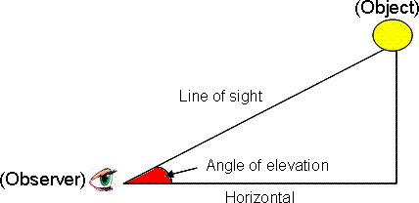

* The **angle of depression** of an object viewed is the angle formed by the line of sight with the horizontal when it is below the horizontal level, i.e., the case when we lower our head to look at the object.

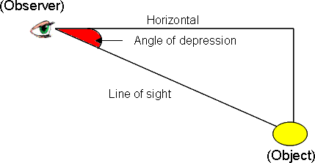

# Pythagoras theorem

It states that “In a right triangle, square of the hypotenuse is equal to the sum of the square of the other two sides”.

* When any two sides of a right triangle are given, its third side can be obtained by using Pythagoras theorem.

# Reflection from the water surface

In case of reflection from the water surface, the two heights above and below the ground level are equal in length.